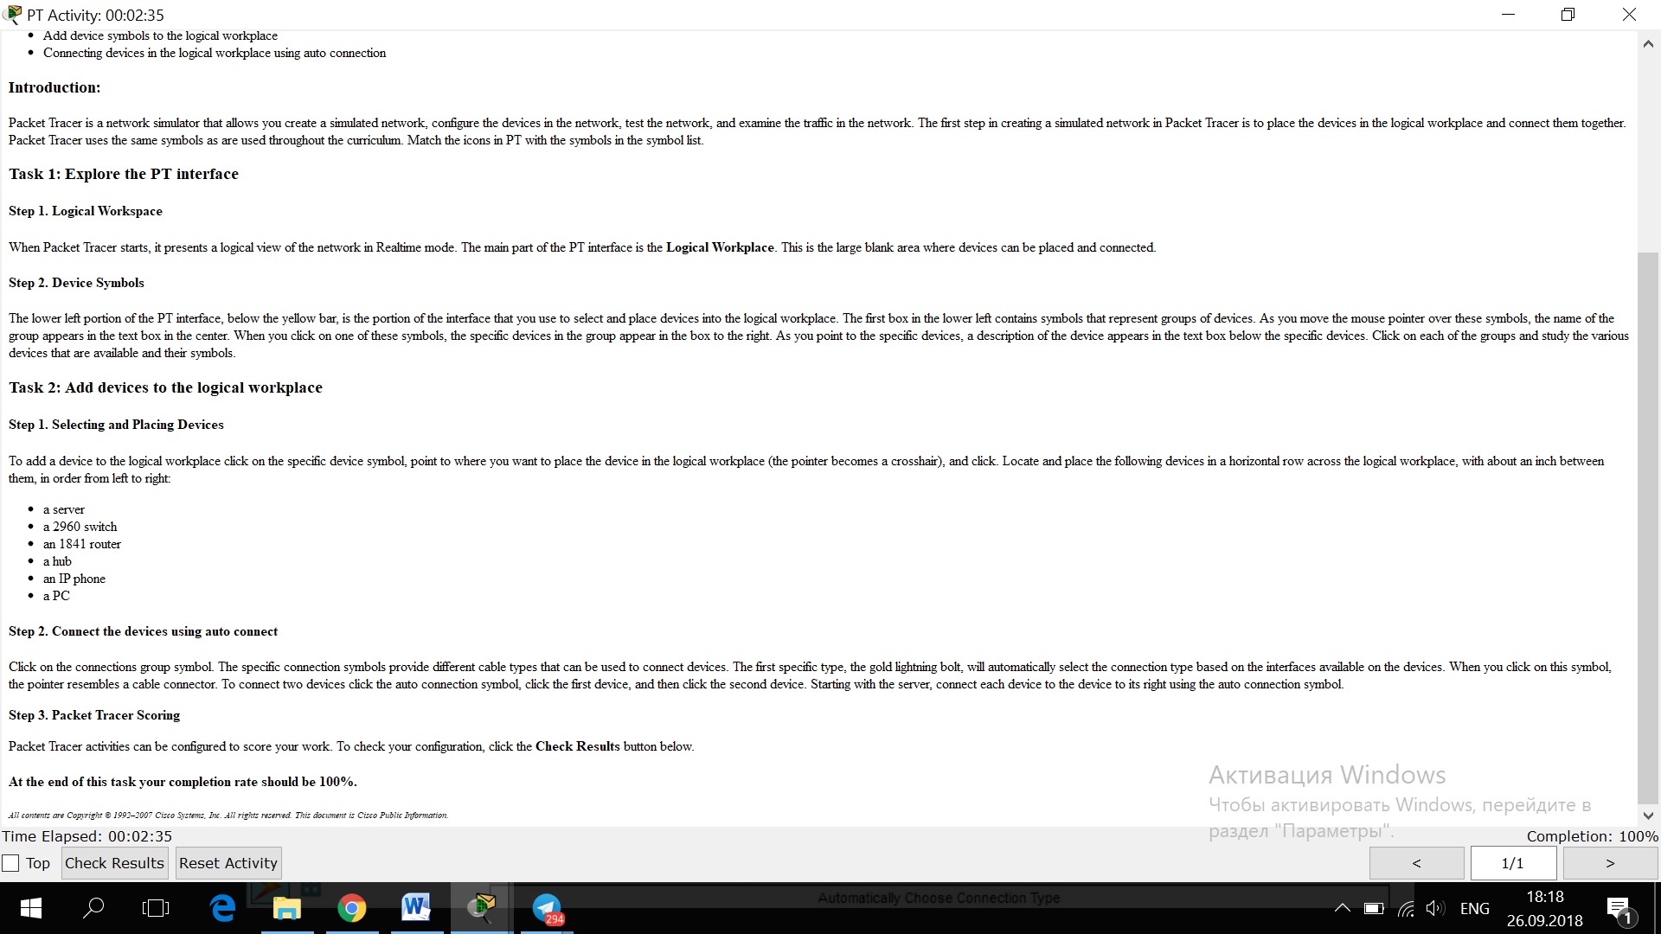

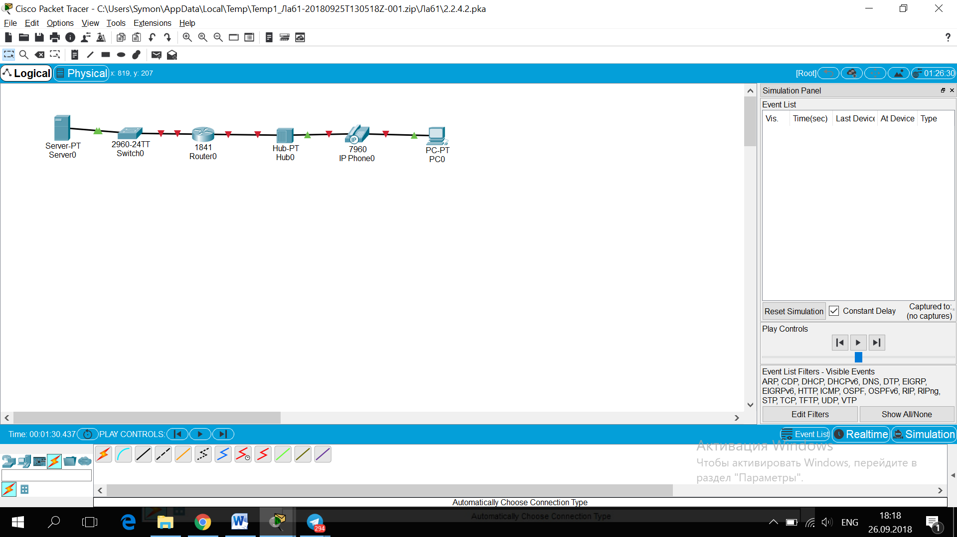

**Activity 2.6.1:   
Topology Orientation and Building a Small Network**

**Addressing Table**

This lab does not include an addressing table.

**Learning Objectives**

* Correctly identify cables for use in the network
* Physically cable a peer-to-peer
* Verify basic connectivity on each network

**Introduction:**

Many network problems can be fixed at the Physical layer of a network. For this reason, it is important to have a clear understanding of which cables to use for your network connections.

At the Physical layer (Layer 1) of the OSI model, end devices must be connected by media (cables). The type of media required depends on the type of device being connected. In the basic portion of this lab, straight–through or patch—cables will be used to connect workstations and switches.z>.

In addition, two or more devices communicate using assigned addresses. The Network layer (Layer 3) requires a unique address (also known as a logical address or IP Addresses), which allows the data to reach the appropriate destination device.

Addressing for this lab will be applied to the workstations and will be used to enable communication between the devices.

Click the **>**(next) button to continue.  
  
*All contents are Copyright © 1992–2007 Cisco Systems, Inc. All rights reserved. This document is Cisco Public Information.*

### Task 1: Create a Peer-to-Peer Network

#### Step 1. Select a Lab Partner

#### Step 2. Obtain equipment and resources for the lab.

Equipment needed:

* 2 workstations
* 1 Ethernet cable

#### At the end of this task your completion rate should be 0%.

Click the **>**(next) button to continue.  
  
*All contents are Copyright © 1992–2007 Cisco Systems, Inc. All rights reserved. This document is Cisco Public Information.*

Before the devices can be cabled, you will need to identify the types of media you will be using. The cables used in this lab are crossover and straight-through.

Use a **crossover cable**to connect two workstations to each other through their NIC’s Ethernet port. This is an Ethernet cable. When you look at the plug you will notice that the orange and green wires are in opposite positions on each end of the cable.

Use a **straight-through cable**to connect the router’s Ethernet port to a switch port or a workstation to a switch port. This is also an Ethernet cable. When you look at the plug you will notice that both ends of the cable are exactly the same in each pin position.

#### Step 1. Cable the Peer-to-Peer Network.

Using the correct Ethernet cable, connect two workstations together. Connect one end of the cable to the NIC port on PC1 and the other end of the cable to PC2.

Which cable did you use?

#### At the end of this task your completion rate should be 33%.

Click the **>**(next) button to continue.  
  
*All contents are Copyright © 1992–2007 Cisco Systems, Inc. All rights reserved. This document is Cisco Public Information.*

### Task 3: Configure addresses and test

#### Step 1. Apply a Layer 3 address to the workstations.

To complete this task, you will need to follow the step-by-step instructions below.

* Click the PC you want to assign an address to.
* Click the **Desktop** tab
* Click the **IP Configuration** tab
* In the **IP address**box, enter the IP address 192.168.1.2 for PC1. (Enter the IP address 192.168.1.3 for PC2.)
* Press the tab key and the Subnet mask is automatically entered. The subnet address should be 255.255.255.0. If this address is not automatically entered, enter this address manually
* Close the IP configuration window by clicking on the X

#### Step 2. Verify connectivity.

To test Connectivity follow the following instructions:

* Click **PC1**
* Click the **Desktop** tab
* Click the **Command Prompt** tab
* Type **ping 192.168.1.3** then press *enter*

What is the output of the **ping** command?

If the ping command displays an error message or doesn’t receive a reply from the other workstation, troubleshoot as necessary. Possible areas to troubleshoot include:

* Verifying the correct IP addresses on both workstations
* Ensuring that the correct type of cable is used between the workstations

What is the output of the ping command if you unplug the network cable and ping the other workstation?

#### At the end of this task your completion rate should be 100%.

*All contents are Copyright © 1992–2007 Cisco Systems, Inc. All rights reserved. This document is Cisco Public Information.*

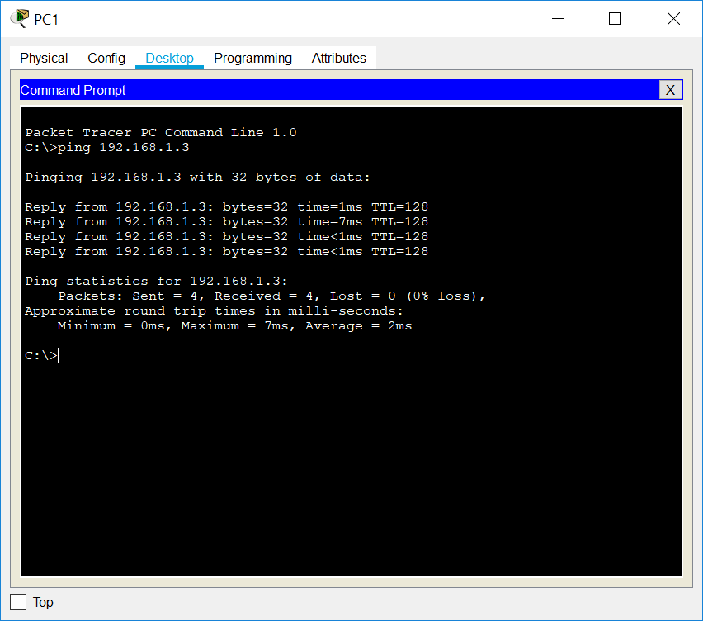

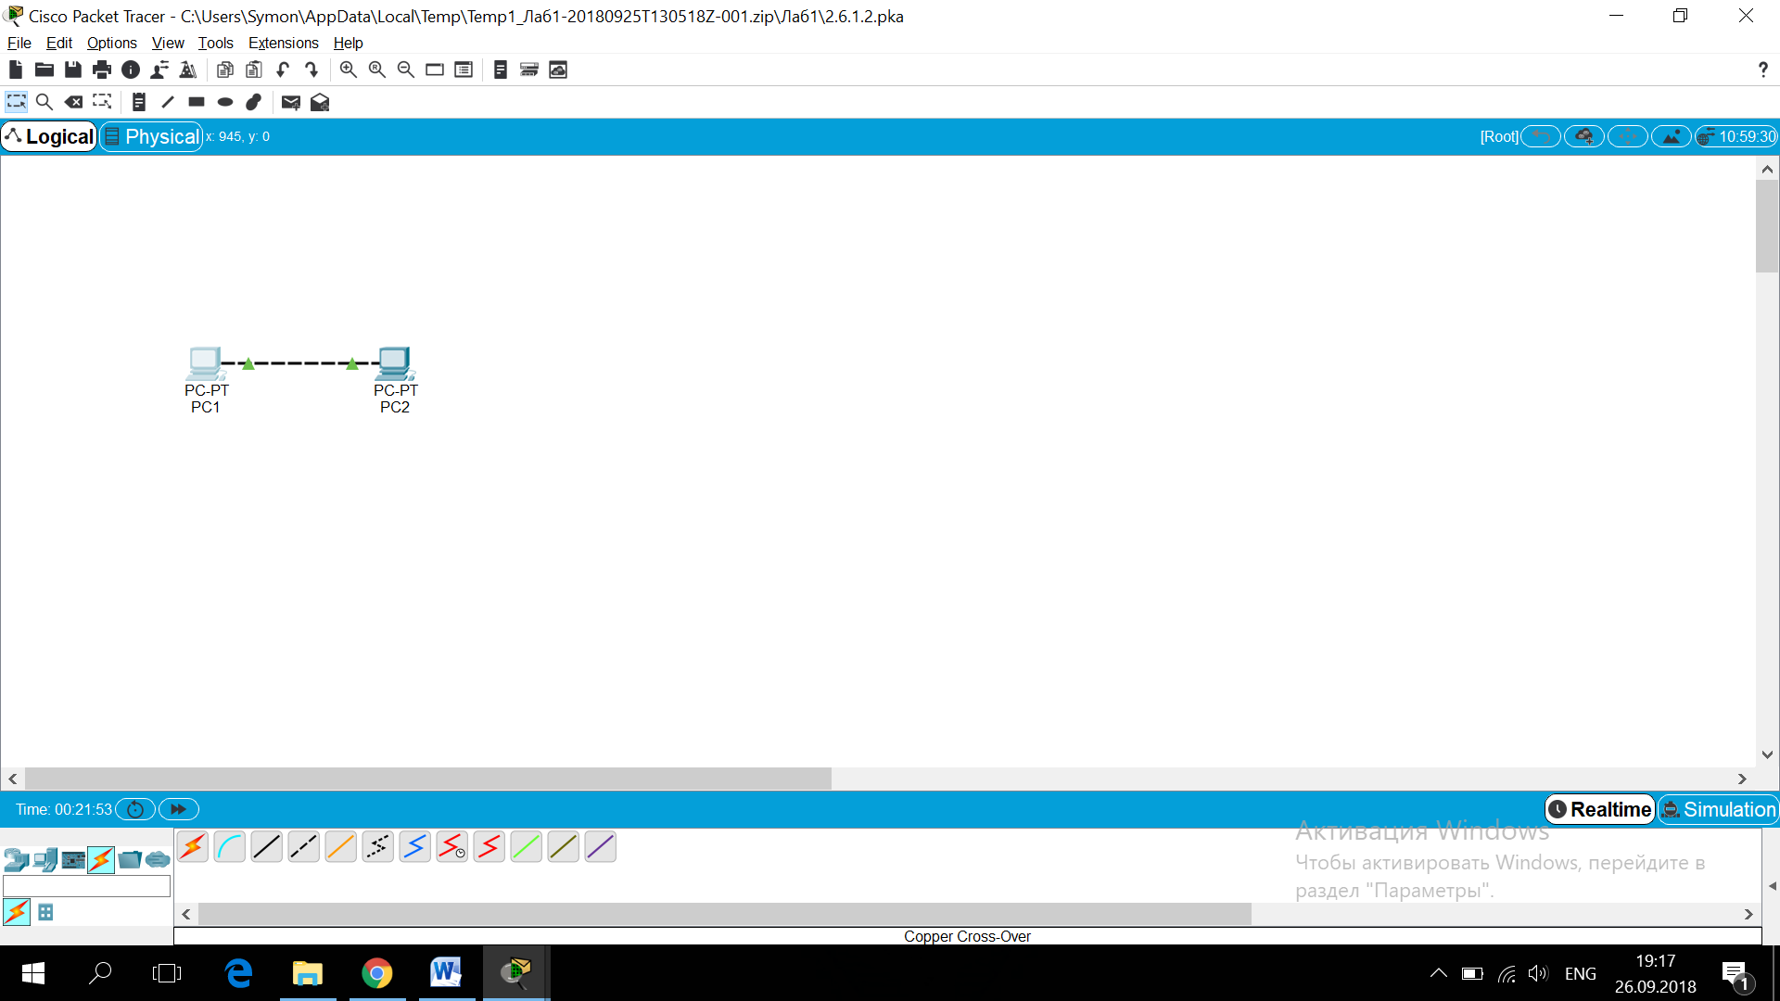

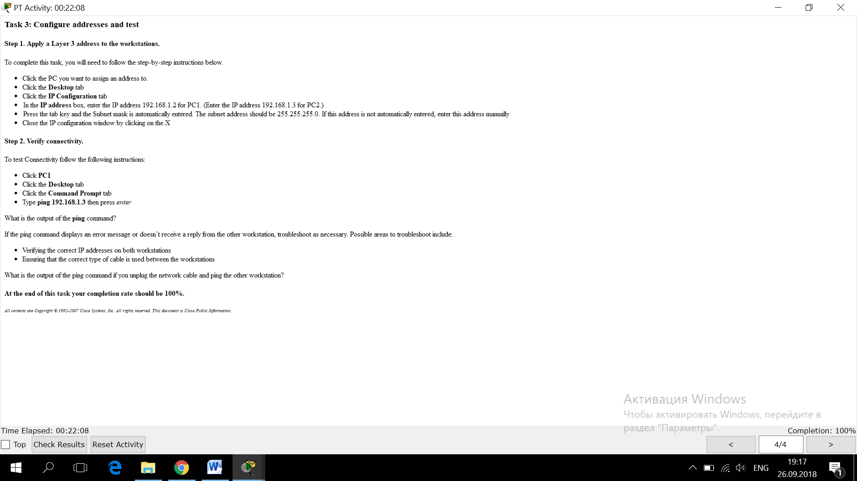

**2.7.1: Skills Integration Challenge-Examining Packets**

**Topology Diagram:**

A nearly complete standard lab topology is provided as starting point.

|  |  |  |  |  |
| --- | --- | --- | --- | --- |
| **Device** | **Interface** | **IP Address** | **Subnet Mask** | **Default Gateway** |
| **R1-ISP** | **Fa0/0** | 192.168.254.253 | 255.255.255.0 | N/A |
| **S0/0/0** | 10.10.10.6 | 255.255.255.252 |
| **R2-Central** | **Fa0/0** | 172.16.255.254 | 255.255.0.0 | N/A |
| **S0/0/0** | 10.10.10.5 | 255.255.255.252 |
| **S1-Central** | **VLAN 1** | 172.16.254.1 | 255.255.0.0 | 172.16.255.254 |
| **PC 1A** | **NIC** | 172.16.1.1 | 255.255.0.0 | 172.16.255.254 |
| **PC 1B** | **NIC** | 172.16.1.2 | 255.255.0.0 | 172.16.255.254 |
| **Eagle Server** | **NIC** | 192.168.254.254 | 255.255.255.0 | 192.168.254.253 |

**Learning Objectives:**

* Complete the Topology
* Add Simple PDUs in Realtime Mode
* Analyze PDUs in Simulation Mode
* Experiment with the model of the standard lab setup

**Background:**

Throughout the course, you will be using a standard lab setup created from actual PCs, servers, routers, and switches to learn networking concepts. In this activity, you will continue learning how to build and analyze this standard lab topology. If you have not done so already, you are encouraged to examine the Help files available from the Help Pull-down menu at the top of the Packet Tracer GUI. Resources include a "My First PT Lab" to help you learn the basic operation of Packet Tracer, tutorials to guide you through various tasks, and information on the strengths and limitations of using Packet Tracer to model networks.  
  
This activity will provide an opportunity to explore the standard lab setup using Packet Tracer simulator. Packet Tracer has two file formats it can create: .pkt files (network simulation model files) and .pka files (activity files for practice). When you create your own networks in Packet Tracer, or modify existing files from your instructor or your peers, you will often use the .pkt file format. When you launched this activity from the curriculum, these instructions appeared. They are the result of the .pka, Packet Tracer activity file format. At the bottom of these instructions are two buttons: Check Results (which gives you feedback on how much of the activity you have completed) and Reset Activity (which starts the activity over, if you want to clear your work or gain more practice).

**Task 1: Complete the Topology**

Add a PC to the workspace. Configure it the following parameters: IP Address 172.16.1.2, Subnet Mask 255.255.0.0, Default Gateway 172.16.255.254, DNS Server , Display Name "1B" (do not include the quotation marks). Connect PC 1B to the Fa0/2 port of the S1-Central Switch and check your work with the **Check Results** button to see that the topology is complete.

**Task 2: Add Simple PDUs in Realtime Mode**

Wait until the switch link lights are green. Using the Add Simple PDU, send a test message between PC 1B and Eagle Server. Note that this packet will appear in the lower right as a user created PDU that can be manipulated for testing purposes. The first time you issue this one-shot ping message, it will show as**Failed**--this is because of the ARP process, which will be explained later. Double clicking the "Fire" button in the PDU List Window, send this single test ping a second time. This time it will be successful. Please do this prior to the next task.

**Task 3: Analyze PDUs in Simulation Mode (Packet Tracing)**

Switch to simulation mode. Use the **Capture / Forward** button to move the packet through the network. Click on the packet envelope, or on the colored square in the Info column of the Event List, to examine the packet at each step in its journey. 

**Task 4: Experiment with the model of the standard lab setup**

The standard lab setup will consist of two routers, one switch, one server, and two PCs. Each of these devices is pre-configured. Try creating different combinations of test packets and analyzing their journey through the network.

**Reflection:**

If you have not already done so, you are encouraged to obtain Packet Tracer from your instructor and complete My First PT Lab (available by using the HELP Pulldown Menu and choosing CONTENTS).

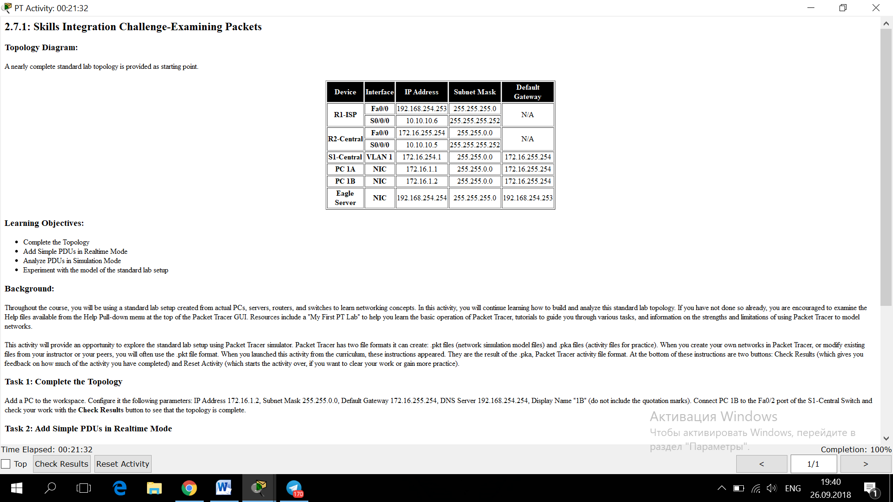

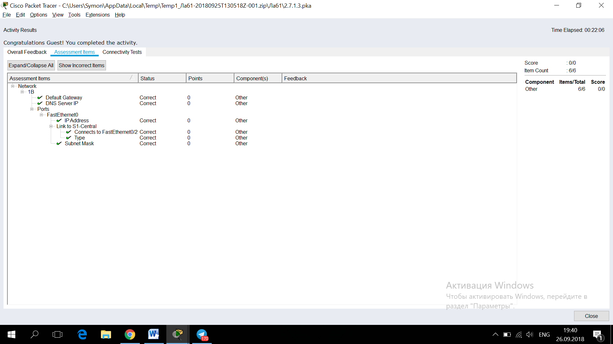

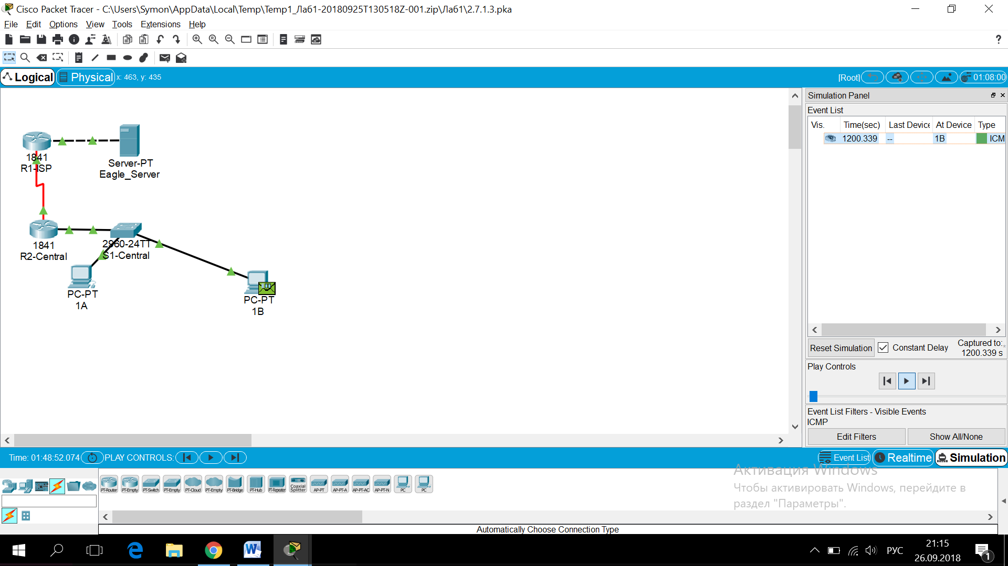

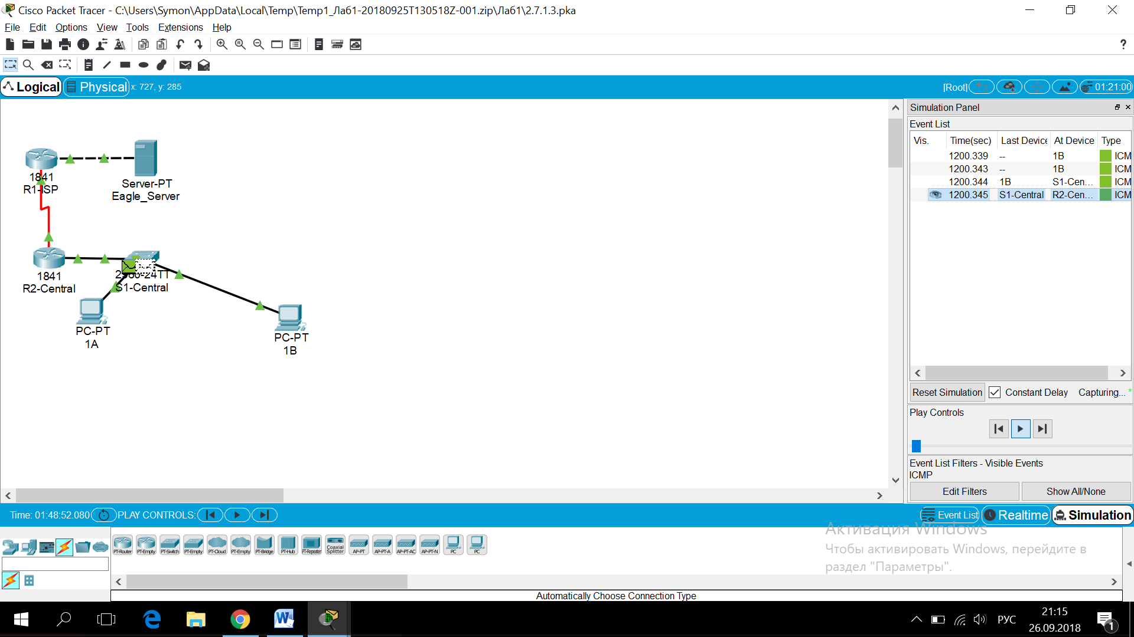

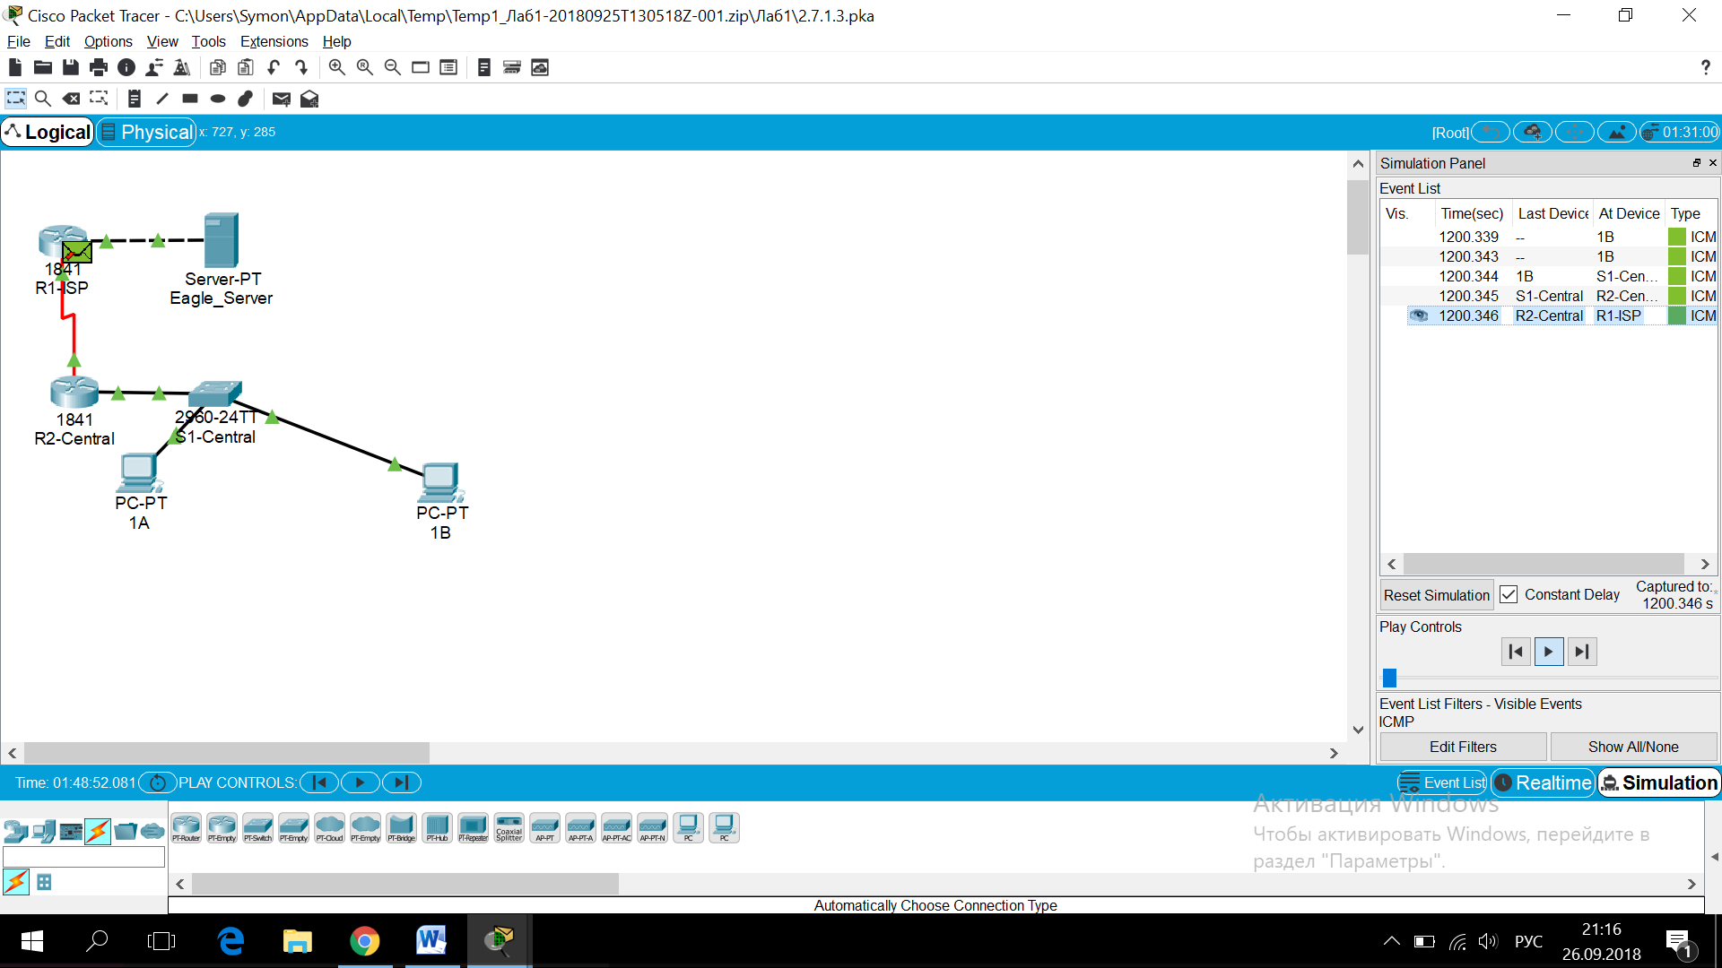

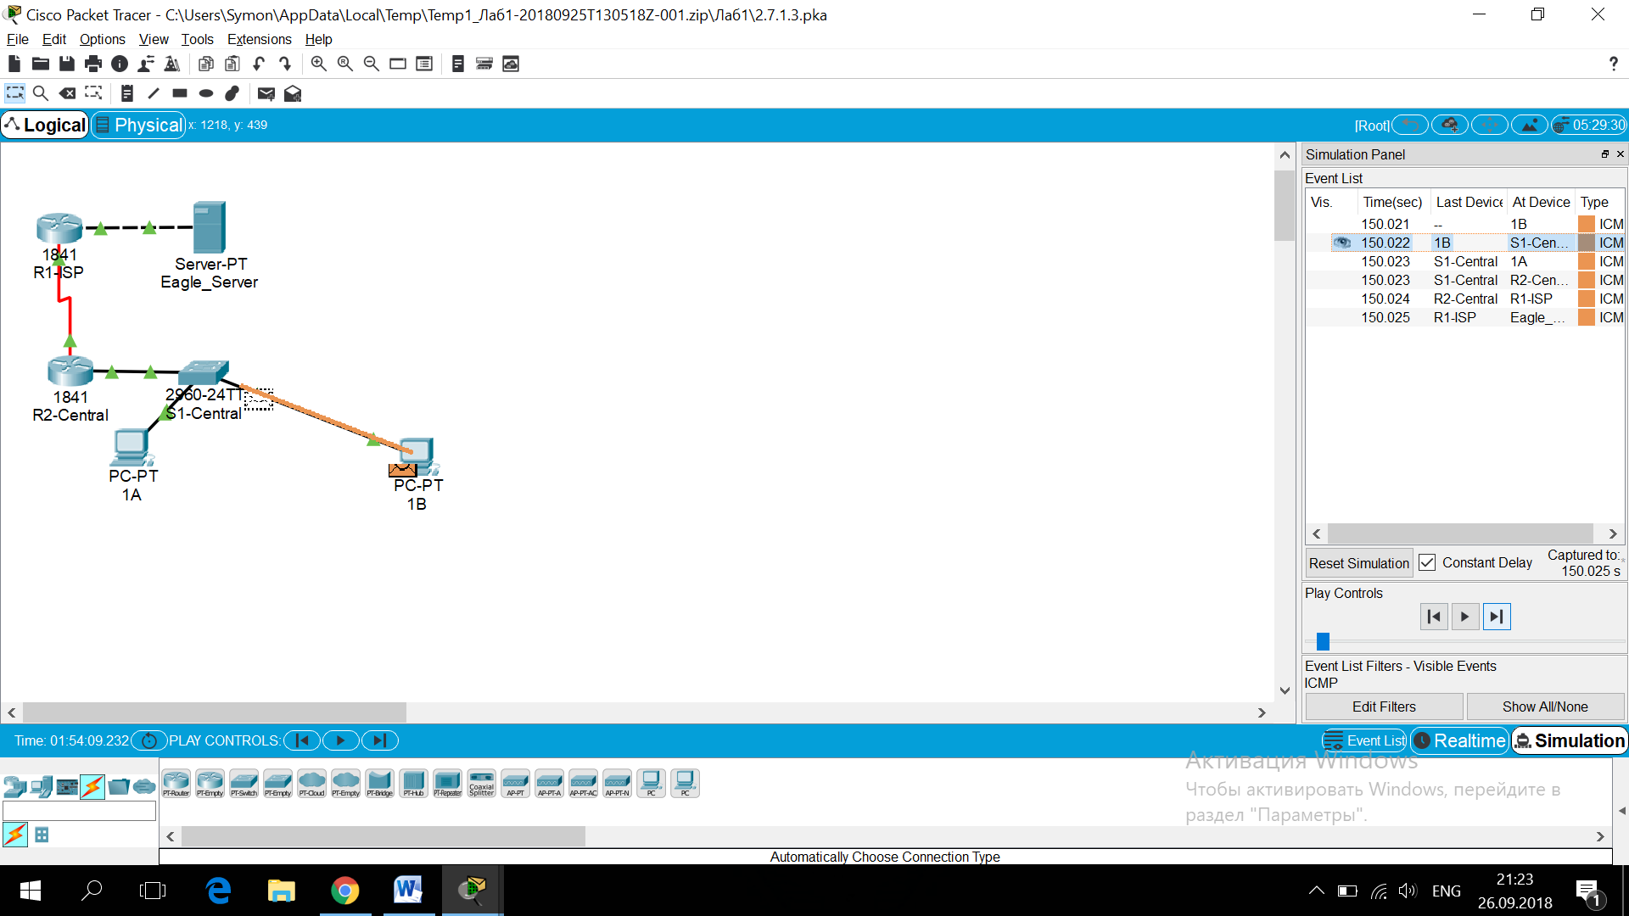

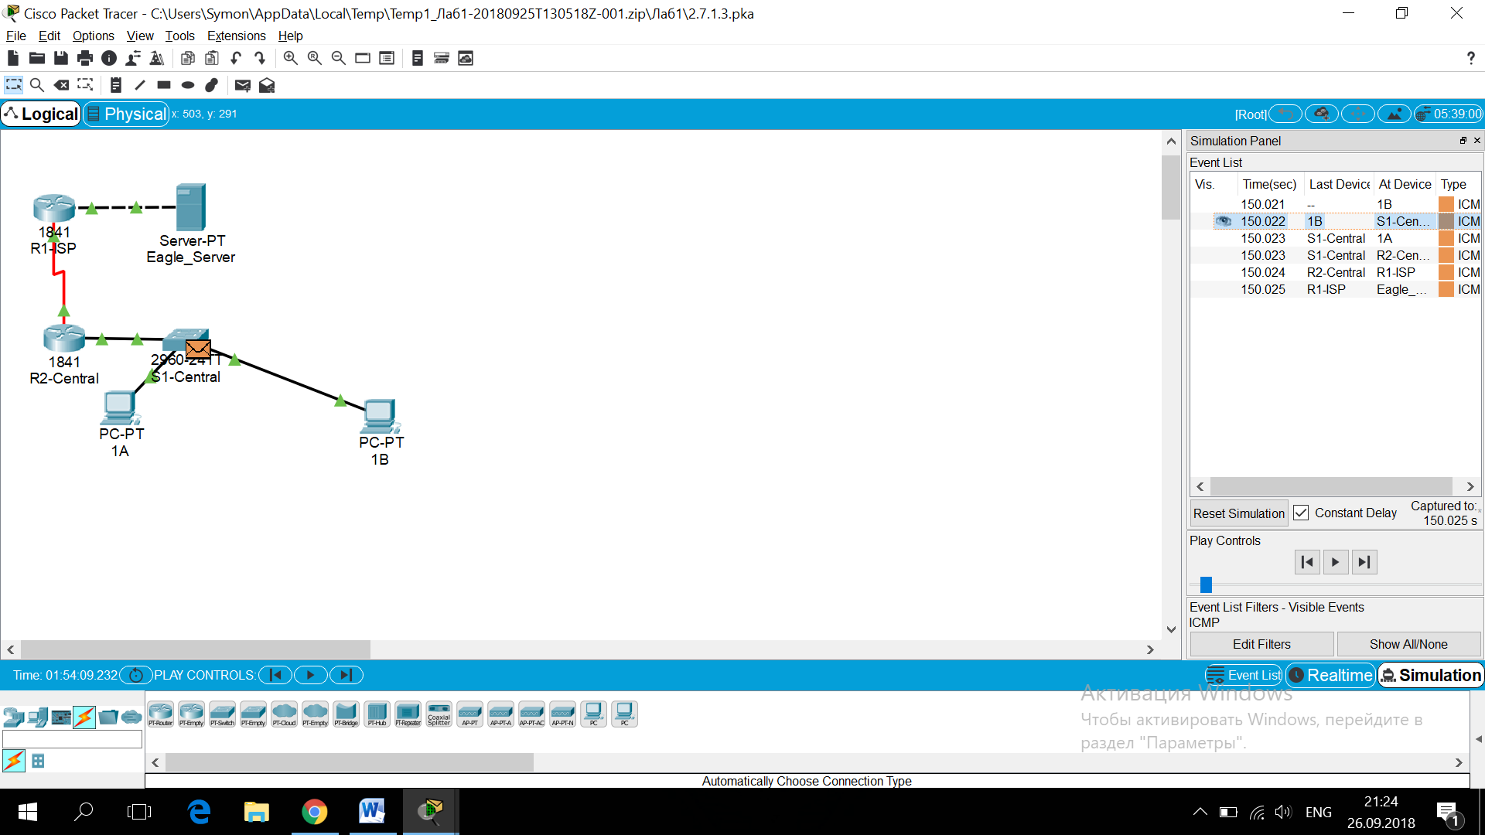

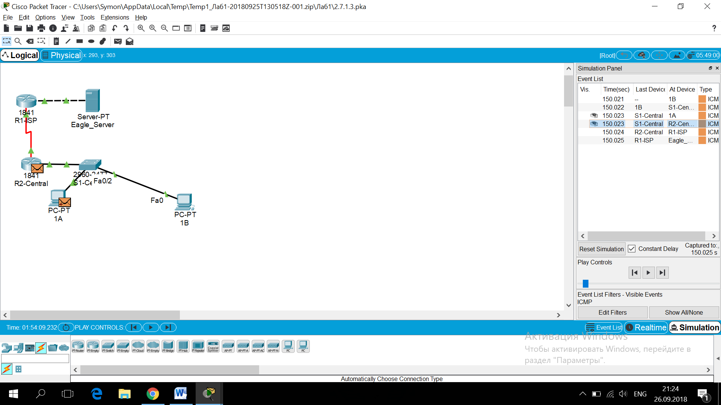

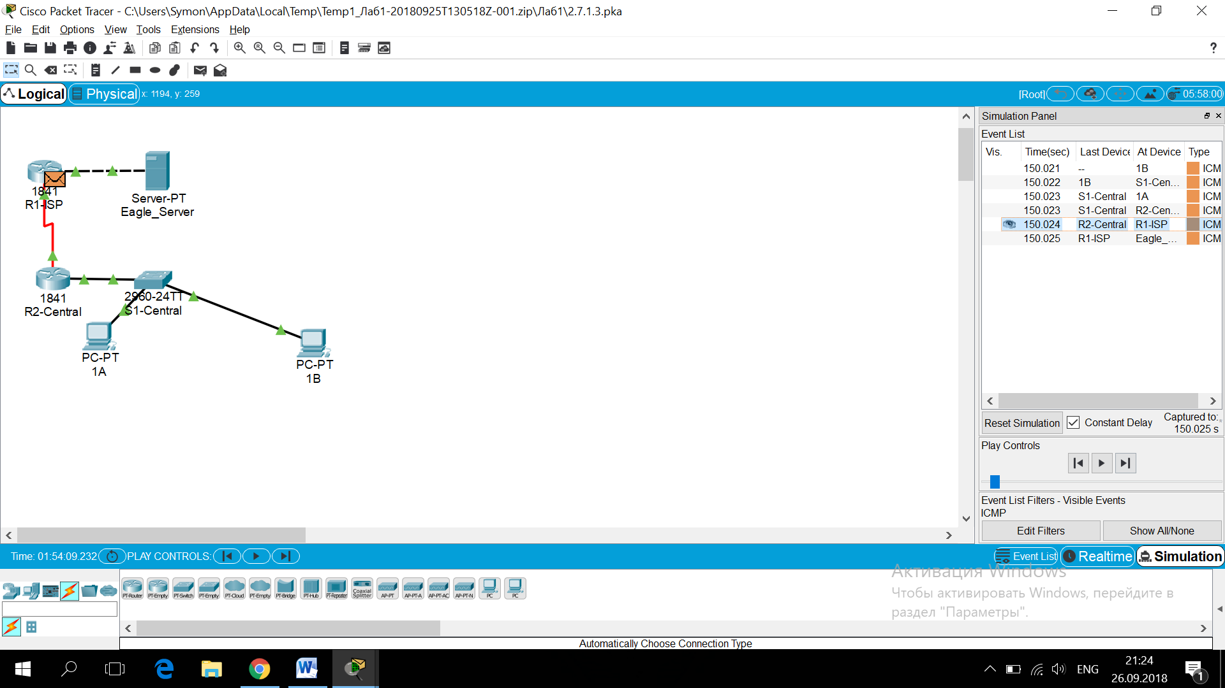

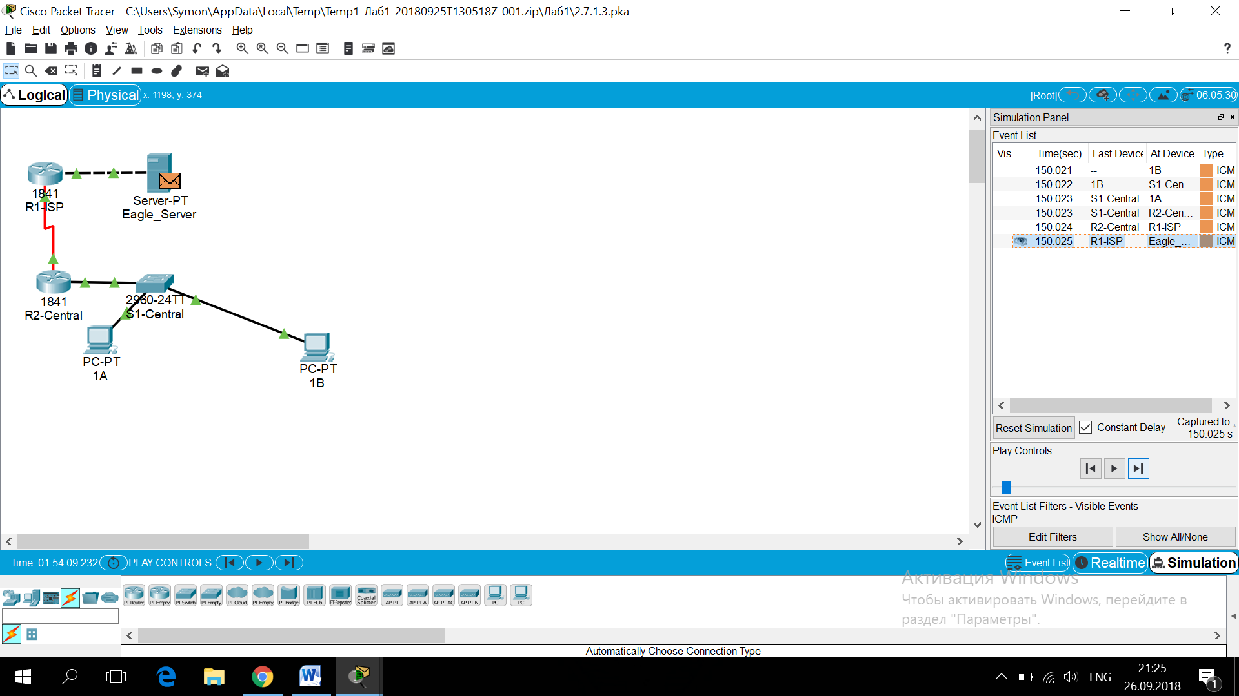

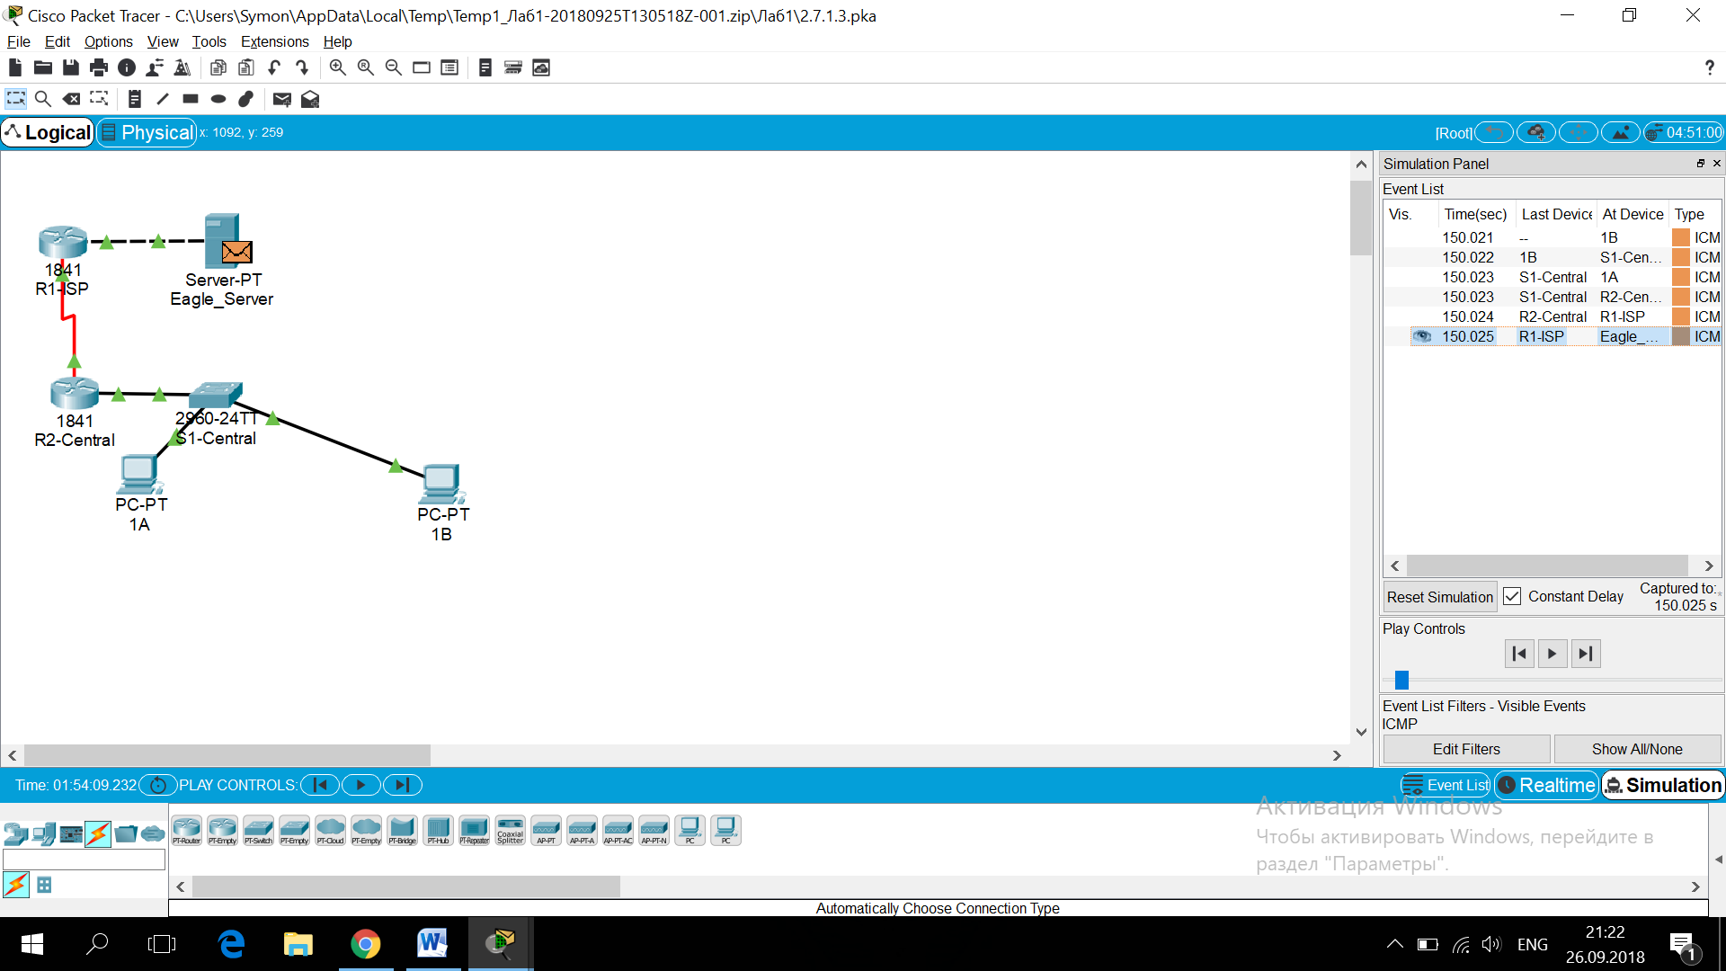

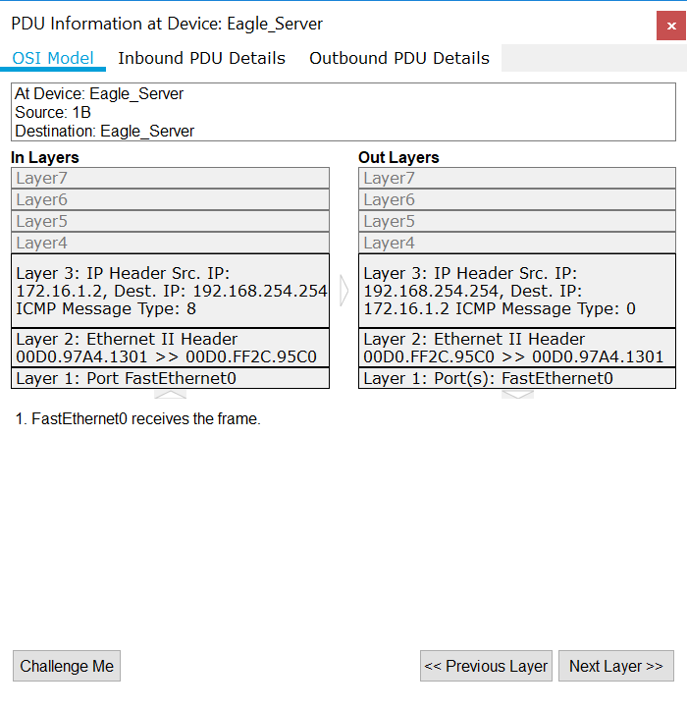

4)

